Chapter 18, Problem 59.

For the linear system in Fig. 18.54, when the input voltage is v_{i}(t) = 2δ(t) V, the output is v_{o}(t) = 10e^{-2t} – 6e^{-4t} V. Find the output when the input is
v_{i}(t) = 4e^{-t} u(t) V.

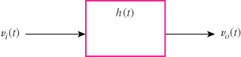

Figure 18.54
For Prob. 18.59.

